Press Release
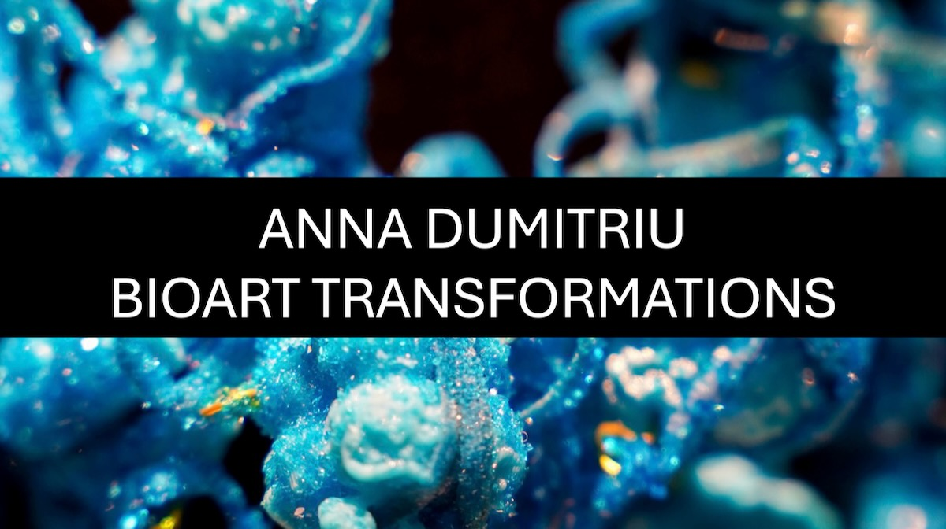
Art and science combine in “BioArt Transformations”, a cutting-edge new exhibition by internationally acclaimed contemporary artist Anna Dumitriu which will open at the will open at the Regency Town House Basement Annexe in the City of Brighton and Hove on the 5th May 2026.
A pioneer of the BioArt movement, Dumitriu works with living bacteria, DNA, and technology to create intricate sculptures, installations and textile works that draw threads across time from the history of science and medicine to cutting-edge research in synthetic biology, genomics and AI. Her strange and affecting objects take the form of relics of Dumitriu’s sublime laboratory-based processes created in contemporary biotechnological research settings, interwoven with historic stories of contagion and alchemy.
A visually stunning and deeply thought-provoking experience, this exhibition is a must-see for the curious, challenging our view on the future of medicine, technology, and humanity.
There will be a series of events throughout the exhibition. Book for these via the artist’s website https://annadumitriu.co.uk/
Anna Dumitriu said: “I am very honoured to hold this major new exhibition in the evocative location of the Regency Town House Basement Annexe as part of the Brighton Fringe Festival and the Artists Open Houses Festival. I’m excited to premier new works created in collaboration with scientists and researchers from across the world, alongside major existing works.
Artworks in the exhibition incorporate a range of media including 3D printed metal, DNA, sterilised bacteria, altered found artefacts and textiles.
Venue
Regency Town House Basement Annexe, 10 Brunswick Square, Hove, BN3 1EG
Exhibition Opening Hours
11am -5pm on 5th May 2026 – 17th May 2026
Events
*Opening event with refreshments: 5pm on 5th May 2026 - meet the artist and science collaborators
*Guided tour with Anna Dumitriu 9th, 10th, 16th and 17th May at 12 noon and 3pm.
Notes to Editors
* For interviews and further information, contact: press@annadumitriu.co.uk or +44 (0)7890 516510
* High-resolution images of the artworks can be downloaded at the following link:
https://www.dropbox.com/scl/fo/roq12yyq2s6rzs11mrjyd/AIbqSjhQz5avvo-J-dnNWOc?rlkey=adu2yptwk37z9rit5y9w8kezq&dl=0
and should be credited to Anna Dumitriu unless otherwise stated in the file name
* Anna Dumitriu’s Biography and Website
Anna Dumitriu is an internationally renowned pioneering British contemporary artist who works with BioArt, sculpture, installation, and digital media to explore our relationship with nature and technology focussing on infectious diseases, synthetic biology, AI and robotics.
Past exhibitions include ZKM, Ars Electronica, BOZAR, The Picasso Museum, Kunstlerhaus Vienna, MIT Museum, HeK Basel, the Nobel Prize Museum, Science Gallery Bengaluru, MOCA Taipei, Art Laboratory Berlin, the History of Science Museum Oxford, the 6th Guangzhou Triennial and Eden Project.
She holds visiting research fellowship/artist-in-residence roles at the University of Hertfordshire, the University of Cranfield and the National Institute of Health Research Leeds Biomedical Research Centre, and an artist-in-residence roles with Modernising Medical Microbiology at the University of Oxford, and the Wellcome Sanger Institute. She was the 2018 President of the Science and the Arts Section of the British Science Association. Her work has featured in many significant publications including Frieze, Artforum International Magazine, Leonardo Journal, The Art Newspaper, Nature and The Lancet.
Dumitriu was part of the duo who created the Black Rock Beachcombers series of three public sculptures on Brighton beach along the boardwalk between the Volks Railway Workshop and the Reading Room cafe.
https://annadumitriu.co.uk/
* Regency Town House Basement Annexe
https://www.rth.org.uk/
*Image Credit
Cellular Reprogramming Necklace by Anna Dumitriu, photo Audrey Rose Mizzi

